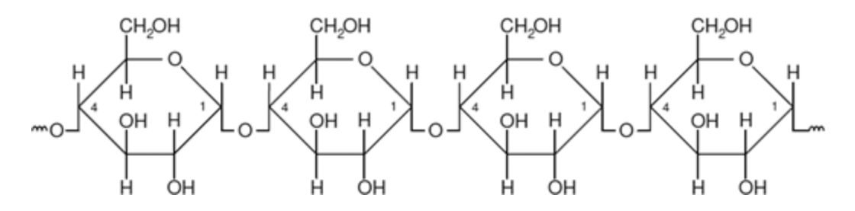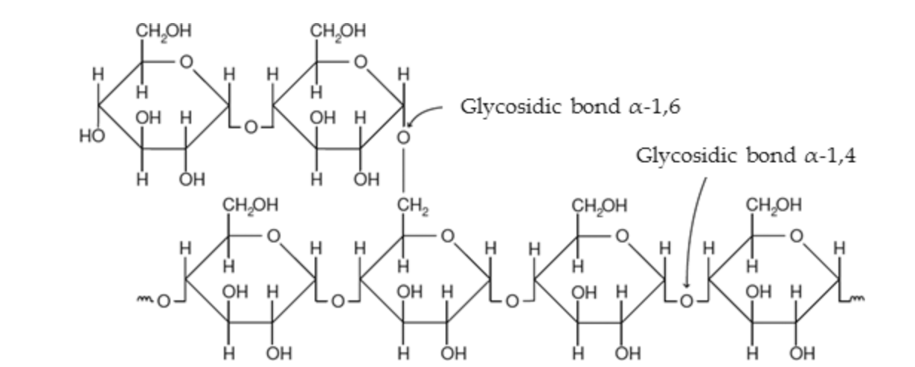

**Amylose Amylopectin**

**Thermoplastic Starch TPS**

* Starch granules are structurally modified into TPS using plasticizers (water and/or glycerol (C3H8O3) /sorbitol) when it is processed with a low water content and the action of shear force and temperature in the presence of the plasticizers which do not evaporate easily during the processing → spontaneous destructurization
  + High temp, high shear condition, low water
* Abundant in plants as amorphous and crystalline granules
* TPS is made by applying mechanical and thermal energy onto the starch granules by adding plasticizer
  + Plasticizers decrease internal h bonding → processability, flexibility, and mobility due to less water affinity
* Use twin-screw extruder followed by takeoff device to make TPS films

Structure

* Polysaccharide consisting of D-glucopyranose (aka Glucose with OH projecting to the right) units joined by α-1,4 linkages and is hydrophilic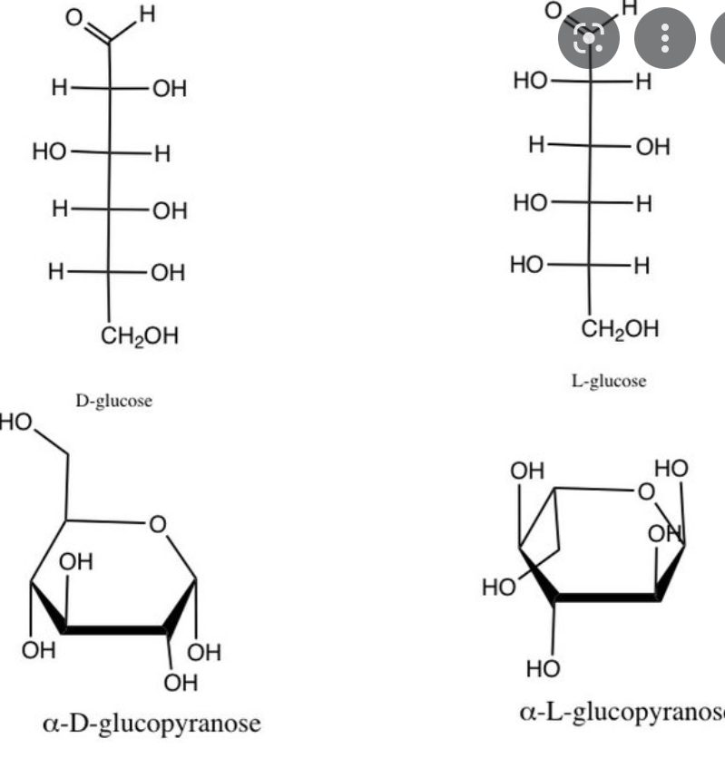
* 2 polymers of high molecular weight: Amylose (10-20%) and Amylopectin (80-90%)
  + Amylose: hydrophilic helical structure → H bonding through Hydroxyl groups (can also be oxidized and reduced)
    - 200–20,000 glucose units
  + Amylopectin: high molecular weight, v little branching
    - 10,000 and 20,000,000 glucose units
* Starch naturally occurs as hydrophilic granules w lots of H bonding

Poor Mechanical and Physical Properties

* Sensitive to high humidity & moisture
  + Improved by Lignin (hydrophobic)
* No clear melting point
* Brittle
* Fragile due to low Tg
* High amylose content → less flexible; high amylopectin content → more flexible
* High solubility in water
  + Starch can be modified by esterification, etherification, and oxidation before thermoplastization to become more hydrophobic
* Low permeability to gasses
* Poor water vapor barrier properties
  + Improved by Cellulose microfibrils (CNF)
    - Increase in tensile strength, a decrease in deformation values, an increase in Young's module, and a decrease in WVP of TPS films
* Plasticizers increase flexibility and processability by decreasing absorption of water
  + Starch-starch interactions replaced by stary-plasticizer interactions

Crystallinity

* Semi Crystallinity due to Amylopectin and Amylose/Amylopectin ratio
  + X ray scattering shows native starch is 20-40% crystalline
* Mechanical resistance and flexibility depend on crystalline region
* Remains solid until a given quantity of heat is absorbed and then rapidly changes into a low viscosity liquid
* Useful levels of strength and stiffness

Other Properties

* Inexpensive and abundant
* Native starch granules are completely biodegradable
* Corn and sugar starch show promise
* Renewable and flexible → easily used in thermoplastification processes

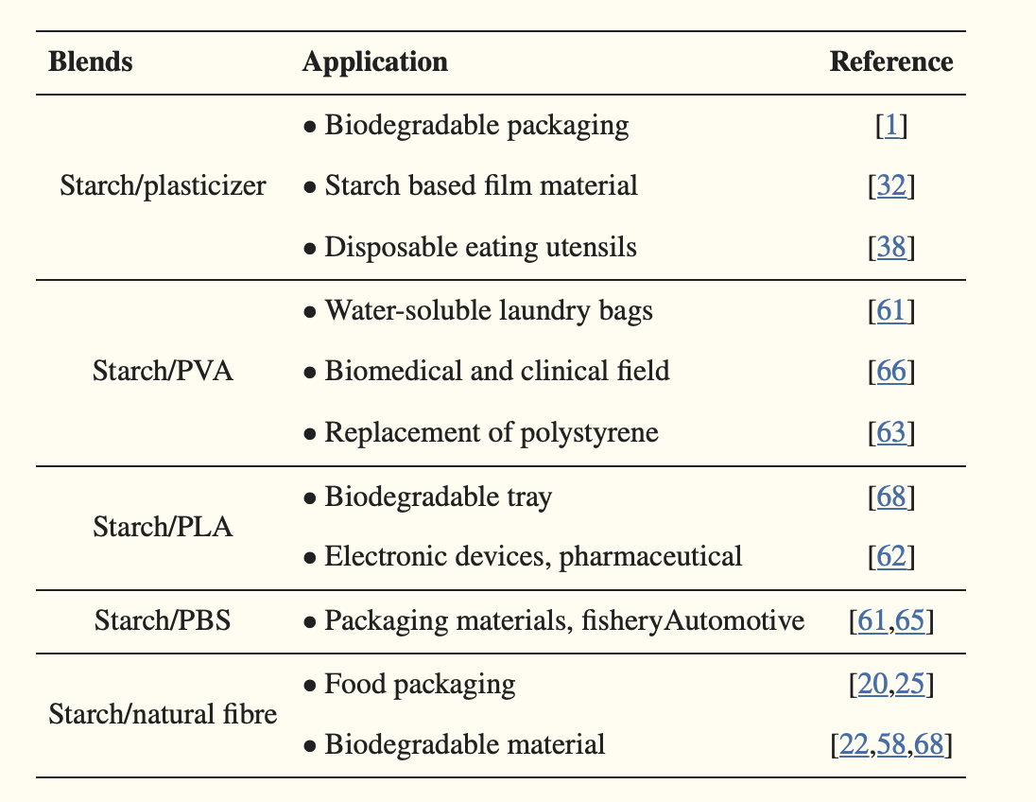

* Certain blends improved tensile strength, decreased moisture affinity, decreased density, decreased health hazards, increased insulation, etc.
* TPS with PLA (hydrophobic) offers the MOST advantage based on cost, properties, and biodegradability
  + Drawbacks: low impact strength, flexibility, ductility
* Ex. PLA decreased the water vapor permeability the most → v important for food trays
* PBS increases impact strength and chemical resistance the most → more flexibility/elasticity → good for food packaging

<https://www.intechopen.com/chapters/52594>

<https://researchrepository.wvu.edu/cgi/viewcontent.cgi?article=4607&context=etd>

<https://www.ncbi.nlm.nih.gov/pmc/articles/PMC8123420/>

https://www.researchgate.net/publication/258211268_Thermoplastic_starches_Properties_challenges_and_prospects